Multiple time ran the below command
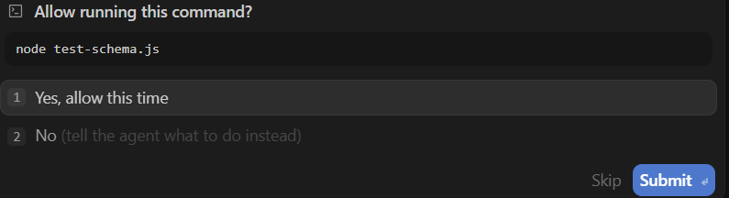
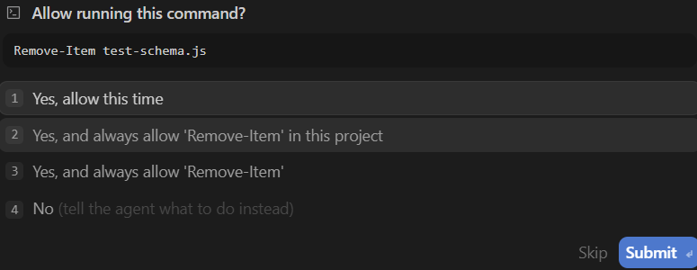
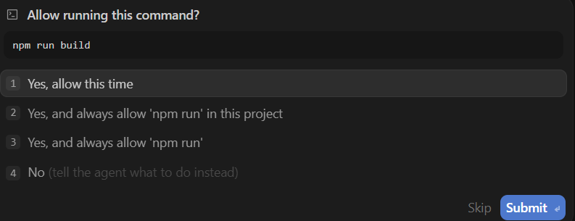

Day 4 Walkthrough - Tasks & Placements Modules
We have built and compiled the Toast Notification System, the Task Manager module, and the Placement Application Tracker module with full integration into your pre-existing Supabase database.

🚀 Features Implemented
1. Toast Notification System
- Context API (ToastContext.jsx): Manages a list of active toasts. Exposes the showToast(message, type) hook supporting success, error, and info styles.
- Floating UI (Toast.jsx): Rendered in the top-right corner using smooth CSS fade/slide transitions and glassmorphism styling. Employs lucide-react status icons.
- Integration: Placed globally in App.jsx.
2. Task Manager (Tasks.jsx)
- Dashboard Stats (TaskStats.jsx): Displays "Tasks Due Today" (compared against local browser date in YYYY-MM-DD format) and "Total Completed Tasks".
- Multi-Tab Layout: Fast navigation between "Today", "All Tasks", and "Completed" views.
- Visual Filters (TaskFilters.jsx): Dropdowns to filter tasks dynamically by priority and category.
- Slide-over Panel (TaskForm.jsx): Creates or edits tasks with inline required-field validation for Title.
- Task Card (TaskCard.jsx):
  - Strikethrough title text when completed.
  - Colored badges for category and priority levels.
  - "Overdue" pill in red if past due date and incomplete.
  - Inline confirmation trigger for deletion.
3. Placement Application Tracker (Placements.jsx)
- Pipeline Metric Header (PlacementPipeline.jsx): A summary dashboard displaying counts for each stage: Applied, OA, Interview, Offer, Rejected. Includes total counters.
- Applications Table (PlacementTable.jsx): Displays company name, role, status badges, applied date, salary, and notes/actions.
- Interactive Status Badge (StatusBadge.jsx): Interactive dropdown allowing instantaneous status updates without opening the full edit form.
- Slide-over Panel (PlacementForm.jsx): Forms to manage company name, role, status, notes, and salary (only shown if status is 'offer', but preserved in state to prevent automatic erasure).
- Notes Slide-over (PlacementNotesPanel.jsx): Right-side slide-over panel display for job application notes.

🛠️ Build Validation
The application was verified by building the production bundle. It completed successfully with zero compiling, syntax, or importing errors:
bash
vite build
✓ built in 1.05s
dist/assets/index-DH4UXUJ-.css 31.45 kB
dist/assets/index-Bv4ob64U.js 517.37 kB
Development Checklist - Day 4
Toast Notification System
- Create client/src/context/ToastContext.jsx
- Create client/src/components/ui/Toast.jsx
- Integrate ToastProvider in client/src/App.jsx
Task Manager Module
- Create client/src/components/tasks/TaskStats.jsx
- Create client/src/components/tasks/TaskFilters.jsx
- Create client/src/components/tasks/TaskForm.jsx
- Create client/src/components/tasks/TaskCard.jsx
- Update client/src/pages/student/Tasks.jsx
Placement Tracker Module
- Create client/src/components/placements/PlacementPipeline.jsx
- Create client/src/components/placements/StatusBadge.jsx
- Create client/src/components/placements/PlacementForm.jsx
- Create client/src/components/placements/PlacementTable.jsx
- Update client/src/pages/student/Placements.jsx
Verification & Build
- Run production build to ensure zero compile errors
- Document manual verification steps

